|  |
| --- |
|  |
| December 2022 Newsletter |
|  |

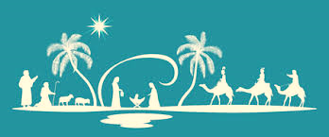 Trinity UCC

101 East Main Street, Thurmont, Maryland 21788

www.trinityuccthurmont.org T: 301-271-2305

A Word from Pastor Elsbury

# WORSHIP SERVICES

**Sunday @ 10:15 a.m.**

**In Church**

and

**Via Zoom**

**Meeting ID: 875 5390 4135**

**Passcode: MD848e**

and

**Facebook**

# UPCOMING EVENTS

***December 11***

*@ 12:30 p.m.,*

*Caroling*

***December 14***

*Slippery Pot Pie Sale*

***December 18***

***9:30 a.m.***

*Coffee Fellowship*

***Christmas Eve Services***

***8:30 p.m.***

**Christmas Celebrations**

All of us enjoy the excitement and fun of a family Christmas. We always anticipate with joy family members coming home and catching up on all the news and happenings with each one. It is always exciting to get a handful of Grandma’s awesome home baked cookies, not even to talk about the delicious meals. There is always a Christmas tree beautifully decorated as well as loaded with wrapped packages. It is difficult to keep your hands off them, especially when you can see your name flashing like a neon sign. One of the high points is always the impatient excitement of watching the young children anxiously trying to wait their turn for a present. I am sure each of us all the way back to childhood like to reminisce about those long passed days and often wish we could re-invent them.

The first Christmas celebrations were quite different in comparison to ours today. Mary and Joseph had a long exhausting seventy-five mile walk from Nazareth to Bethlehem. Then they experienced a disappointing reality—there “was no room for them in the Inn.”   The word “inn” in the Greek is kataluma1 which is translated a “guest chamber,” and that normally defined a room in a private home in the first century, similar to a Bed and Breakfast in our world. However, the details in Luke’s gospel states in chapter two, verse seven that “she brought forth her firstborn Son, and wrapped him in swaddling cloths, and laid him in a manger….”  The word “manger,” in Greek is phasko2, “a crib for fodder.” Naturally, a “crib for fodder” would normally be found in a barn that housed various animals. It seems logical to me that a traveling family finding “no room in the inn” might find this an uncomfortable substitute. It is also obvious to me that their trying to secure a room in an inn speaks to the fact they could financially have afforded the night’s stay.

I have thought on this at times and have wondered if this was not divine intervention that God in his wisdom provided this simple means of housing for his own purpose and reasons. In scriptures we observe God reaching down to and ministering to every level of human beings – from the poorest to the richest. Certainly, this illumination insures us that ALL peoples whether rich or poor, educated or not and of whatever background or race are welcomed by God.  To God be the glory for his indiscriminate love and provision for ALL of mankind. Amen.

Kitchen News

There will be a slippery pot pie (chicken or ham) sale on December 14. In addition to the slippery pot pie at $7.00 per quart and country ham sandwiches at $6.00 each, you may pick up cakes, fruit and cream pies, chicken pies, soups, and dumplings.

Please call 301/271-2305 with your orders **not later** than **December 7**, for pick-up December 14.

Footnotes:  1Strong, James. **The New Strong’s Exhaustive Concordance of the Bible**. Nashville: Thomas Nelson Publishers. 1990.

2Vine, W. E., Merrill F. Unger and William White.  **Vine’s Expository Dictionary of Biblical Words.**  Nashville: Thomas Nelson Publishers. 1985.

21 Sue and Larry Clabaugh

 Trinity’s monthly coffee and fellowship gathering will be held **December 18** from **9:30 –10:00 a.m.**, in the Social Room.

We’re happy to announce that we will go Christmas caroling this year, on Sunday, December 11. We will meet at the church at 12:30 pm, and drive to 4 or 5 shut-in’s homes to sing a few carols. This is always a fun event, and last year we had about 17 people join us to go caroling. We would love for you to join us, and we often bring relatives and grandchildren along for the singing. After caroling, we meet at Alice’s for fellowship and snacks.



8 Judy Stambaugh

18 Terry Frushour

20 Frank Valentine

7

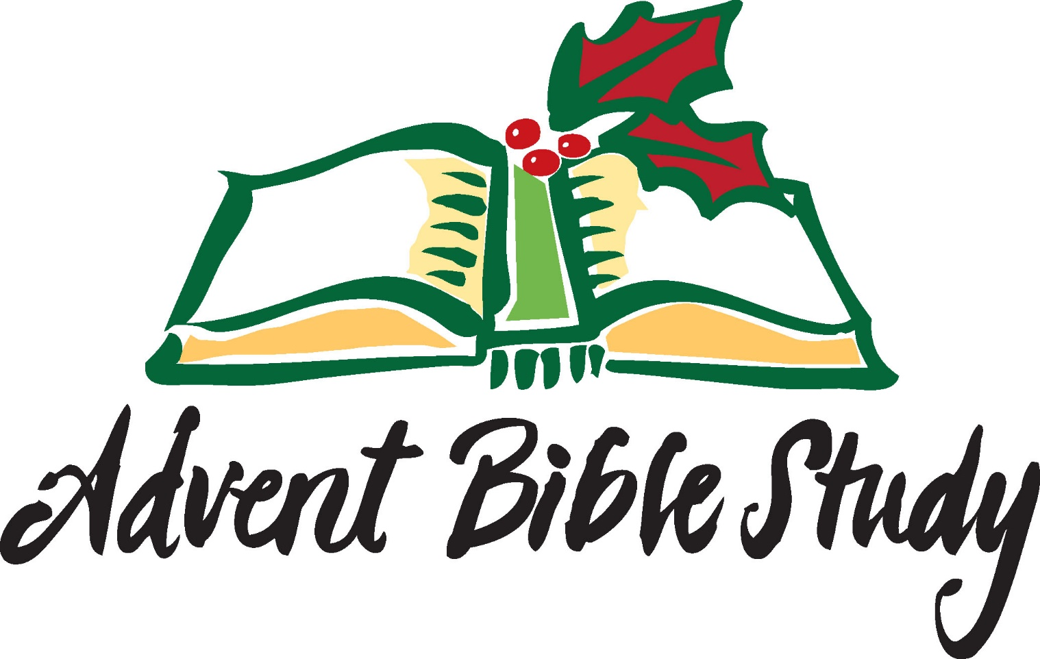**Advent Bible Study**—Pastor Beth Firme and Apples Church are offering an Advent Bible Study on Thursday evenings via Zoom. The study is based on Adam Hamilton’s book, “Prepare the Way for the LORD”. [Prepare the Way for the Lord Book and Bible Study by Adam Hamilton](https://youtu.be/0VOLi6oIgHw) If you have any interest in participating, please email Pastor Beth a tailwinds14@gmail.com.

Council News

The church council met for our monthly meeting on November 16, at Alice’s. We’d like to recap that we had a very nice Veterans Day Service on Sunday, November 6. Thank you to all the participants who helped make this special service possible, to honor the Veterans of our community: Reverend Dale Williams, Sheriff Chuck Jenkins, the American Legion Color Guard, and the Solid Ground Praise Band. The offering collected during the service totaling $278 was donated to the Disabled American Veterans organization.

The Council had a zoom meeting with one of our financial advisors on November 10, and met with the other advisor on November 30. We meet with them several times a year for updates on the church investments.

During the annual maintenance service of the furnace at the Center Street rental property, it was noted some repairs were needed to the furnace. The combustion chamber was replaced and a new oil tank was installed this month. The two-story downspout, on this property, blew down during one of the storms, and was promptly repaired by PJ Roofing.

Pastor Chappell visits members and shut-ins every month. Feel free to give him a call to arrange a visit. He enjoys the visits and would love to chat with you. Blessings to you this month of December as we celebrate Advent and the birth of our savior.

Ross Lillard

The Thurmont Ministerium met on zoom, November the 9th. We are pleased to have found a treasurer for the ministerium. The food bank is seeing an increase in the number of people coming in for groceries, this time of year, and we encourage your donations of food and money to the food bank.

Donations may be mailed to.

Director, Thurmont Food Bank

10 Frederick Rd.

(or P.O. Box 74)

Thurmont, MD 21788

Ministerium Report

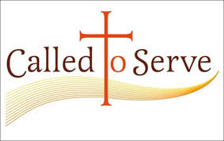

Corey and Natsumi Ellis

Trinity’s Mission Sponsorship

Here’s a bit of the email received from Corey updating us on what’s been happening in his life and ministry.

Remember to keep Corey and Natsumi in your prayers.

**Snapshot of the last month:**

* Natsumi officially changed her name to… Natsumi Koyama Ellis!!!!! Wahhoooo!!
* We had an all campus worship night where The Summit Church’s new worship album was released and some of the testimonies I spent time gathering from our missionaries were shared to the church!
* Our church had a weekend information and training session about Missionary Care!
* I made my first sourdough in our new home!!
* I preached a sermon on Isaiah 35 that I will include a link to here! I would love if you listened and gave me any feedback on something God taught you or ways I could improve!
* I spoke on a panel at the North Carolina Baptist convention for this initiative called the Go2 initiative! It is all about equipping people (mainly college grads) to serve the Lord somewhere strategic for 2 years after graduation.
* I led the practical side of a training for how to do Evangelism! I included a graphic that I made of my notes from the session!
* I dropped some of my best friends off at the airport as they were visiting South Asia!
* Our Missions team went to Richmond to spend some time with the current people being trained by the IMB to go serve as missionaries! We did an escape room!

|  |  |
| --- | --- |
| **What I have been working on:**   * I had been spending a large chunk of my time preparing for the 4 speaking engagements I had over the last month * Sermon on Isaiah 35 [You can use the button below Ctrl + click to hear Corey’s sermon, or type in this link  <https://gmail.us20.list-manage.com/track/click?u=bf6682259f2ac022a186aef38&id=6a4c33d706&e=aac64159dd> * Panel at the NC Baptist Convention * Interest night for college seniors thinking about international missions * Evangelism training * I have also been conducting more interviews regarding the advocacy program. * I have been collecting more testimonies from our current missionaries. * In theology class I completed the next section of my paper on the relation of the physical body of the human with the soul/spirit of the human.  |  | | --- | | [Isaiah 35 Sermon Audio](https://gmail.us20.list-manage.com/track/click?u=bf6682259f2ac022a186aef38&id=6a4c33d706&e=aac64159dd) |  * In class we have also been discussing in detail the doctrines of SIN, crazy stuff!! |

Be sure to join us for our Christmas Eve service this year. It will be on

**Saturday, December 24**

**8:30 pm.**

It is always a nice, peaceful, service with the Christmas message, carols and candles. This year we hoping for some special musical selections.

There will be **no church service on Sunday, December 25**, so our members can enjoy Christmas morning with their family.

***Advent Wreath Tradition***

One of the fondest Advent traditions for both congregations and families is the lighting of Advent candles. The tradition reaches back to pre-Christian northern Europeans. During the darkest days of winter, they lit as many as twenty-four candles on an evergreen-covered wheel or wreath. By lighting a candle a day, they marked time, anticipating the return of the sun’s light and warmth. By the 1500s, both Lutherans and Catholics adapted the Advent Wreath as a devotional way to prepare for the coming of Christ, the Light of the World.

Today, the Advent Wreath is usually an evergreen wreath placed on a table or suspended from a ceiling or an arch. The circle of evergreens reminds Christians of the eternal and ever-renewing promises of Christ. In the wreath are four candles, each candle represents one week during Advent. The lighting of candles, spanning the season, acknowledges the deepening of our preparation and the increasing light that bursts forth at Christmas. Often the candles are purple or blue, noting the season’s expectations of royalty, liberation, redemption, and hope. The first two Sundays focus on the Bible’s prophetic vision of Christ’s future and final return; The third Sunday of Advent has been identified in some traditions as “Gaudete,” a day of joy and rejoicing. We light a pink candle to recognize a shift of Advent themes in the Bible when we concentrate our focus on the coming of Jesus. The fourth Sunday of Advent is when we recount God’s call to Mary and her faithful response. Finally, on Christmas Eve or Christmas Day, a center white candle is lit to symbolize that the light of Christ is fully present. Jesus is born.



Glade United Church of Christ

(Flyer Attached)

Annual Holiday Concert

“Let the Merry Bells Ring”

Wednesday, December 21, 2022 @ 7:00 p.m.

Apples Church

Stephen Gellman and Margaret Wolfe will present an acoustic Christmas Concert

December 10 from 2-3 p.m.

